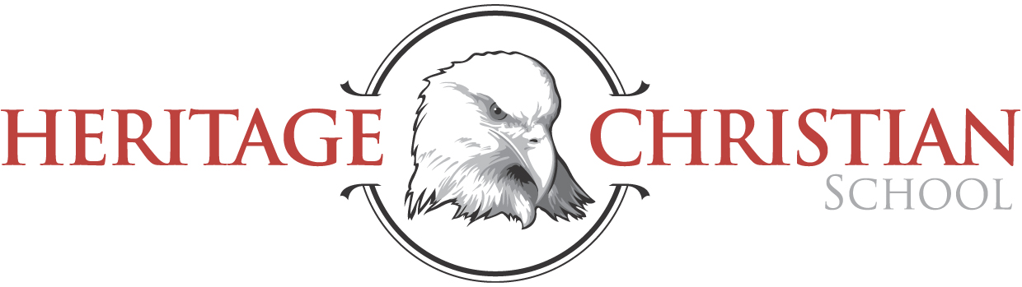

Welcome! Heritage Christian has been providing a Christ-centered, academically-challenging environment to students for over 40 years – founded in 1971 by the Tacoma Bible Presbyterian Church. It is a privilege for us to have educated thousands of children over the years. Families have chosen Heritage as their partner in educating and growing their children for many different reasons, with three reasons in particular standing out:

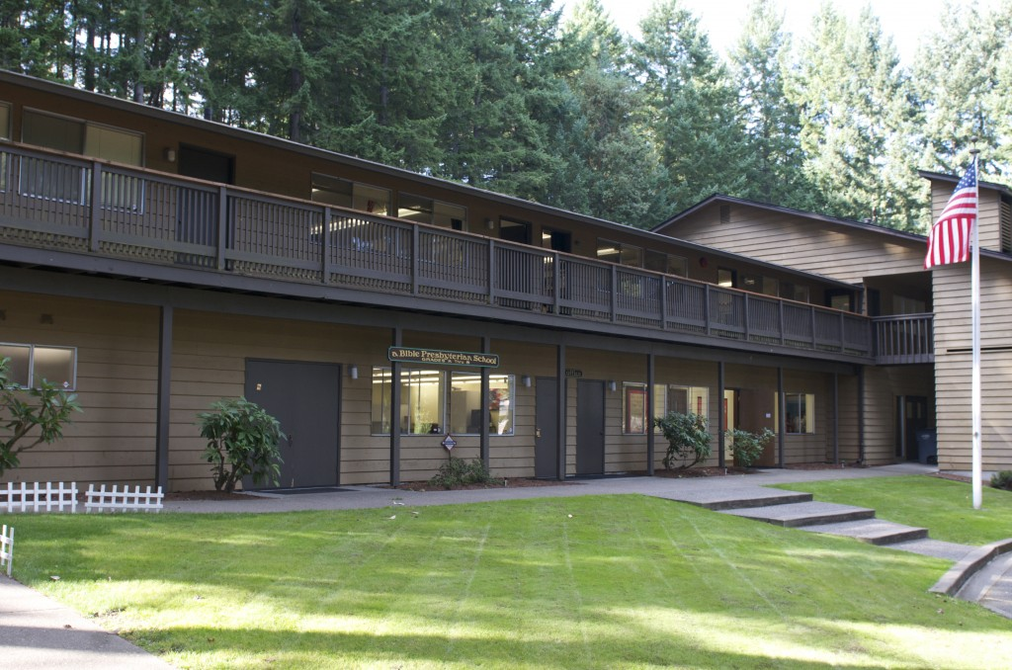
Heritage provides a Christ-centered learning environment. A Heritage education supports families according to Biblical guidelines (Deut. 6:7, Eph. 6:4). Our primary purpose is to lead our students to receive Jesus as Savior, to live according to Biblical truths, and to become responsible citizens. All students enrolled at Heritage memorize Scripture verses each week, as well as selections from the Westminster Catechism. Weekly chapel services include time for musical worship and hearing Biblical messages. Special programs, such as the annual Christmas program, emphasize spiritual truths and involve all students. Our teachers teach from a distinctly Christian worldview throughout every subject area. All these things are done with the desire to instill a love for God and a love for God’s Word in our students’ hearts.

Heritage provides an academically-challenging learning environment. We seek excellence in all things, but especially in academics. We strive to maintain a rigorous academic standard for all our students. Students at Heritage routinely score in the top 20% nationally on standardized exams. Average scores from spring 2014 reflect our commitment to high-quality education:

K-8 Avg. | Reading | Language Arts | Mathematics
 | 90th percentile | 83rd percentile | 85th percentile
Note: Scores are mean NPR scores from 2014 Terra Nova.

Heritage provides the most affordable private Christian education in the area. The economy continues to affect many families. These days, parents must make great sacrifices to provide high-quality private education for their children. Because of our commitment to providing Christian education to as many families and children as possible, we have kept tuition rates as low as possible. The chart below shows the 2016-2017 annual tuition for one elementary and one middle school student at the different private schools in this region. On average, Heritage is $2500/year cheaper for elementary students, and $3000/year cheaper for secondary students.

 | HERITAGE | Tacoma Baptist | Cascade Christian | Concordia Lutheran | Life Christian | Lighthouse Christian
Elementary | $5600 | $6741 | $8280 | $8233 | $8778 | $8300
Secondary | $6150 | $8150 | $10,130 | $8959 | $9658 | $8850

Investing in our children’s education is the best investment a parent can make. We will be praying for your schooling decisions. Please call us at (253) 564.6276 or email us at info@heritagecs.net with any questions.

